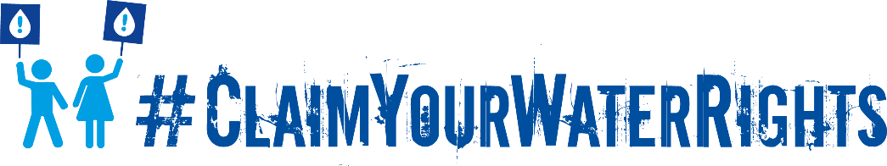
Advocating for climate justice through Claim Your Water Rights
What is Claim Your Water Rights?
Claim Your Water Rights is a global public pressure campaign aimed at mobilising people to demand their human rights to water and sanitation. Since launching in December 2019, our members have produced impressive results: from securing legislative change in Pakistan to garnering political commitments in Nigeria’s Enugu State, from influencing governments’ Covid-19 responses to supporting numerous communities to successfully claim their rights.
Claim Your Water Rights allows our members to advocate on a range of issues - whether it’s water affordability, disconnections, sanitation workers’ rights or financing. In 2021 and beyond, we will expand the campaign’s scope to include climate justice.
What is climate justice?
Climate justice insists on the historic obligation of countries and corporations who caused the climate crisis to address intergenerational injustices by guaranteeing people’s human rights. Achieving justice depends not only on climate mitigation - I.e. reducing greenhouse gas emissions to limit the impacts of the climate crisis - but also climate adaptation, which focuses on supporting affected communities to adjust to these impacts by realising civil and socio-economic rights like water.
How does the climate crisis affect people’s right to water?
The climate crisis will be felt more severely by people whose rights to safe water are already compromised. Either their right to water is not enshrined in national law, or their access relies on resources (both groundwater and surface water) that have been polluted or over-abstracted because of the prevalence of unsustainable, unregulated practices in major industries (such as intensive agriculture, hydropower, mining, fossil fuel extraction). Climate-induced water stress will only exacerbate these threats, with longer droughts, worse and more frequent flooding, melting glaciers, and increased groundwater contamination.
Undermining people's human rights to water undermines their ability to adapt to the climate crisis. The international human rights framework specifies that water must be “safe, sufficient, accessible, affordable, and acceptable”. For services to be truly climate resilient, we cannot compromise on this standard.
Campaign objective
We will campaign for governments to respect, protect and fulfil the rights of communities whose water is threatened by the climate crisis or harmful industrial practices. We will mobilise our global civil society network to support people to claim their rights to safe water using a variety of tactics, such as protesting, petitioning parliament and lodging complains to regulators or national human rights commissions.

What is our narrative?
The climate crisis threatens billions of people’s rights to safe water. Communities who have contributed least to the crisis pay with their health and livelihoods, while the biggest state and corporate polluters reap the profits and escape the consequences. To lay the foundations for justice, governments must immediately fund the protection of watersheds and the delivery of public water services.
Our narrative must centre people’s dignity and agency as well as the legal obligations of states to respect, protect and fulfil human rights. The obligation to ‘protect’ includes regulating industries, such as gold mining and oil extraction, that frequently violate people’s rights to water and a safe environment. Recent rulings have established a legal precedent for holding international polluters accountable, demonstrating the power of people and litigation. In February, UK mining company Vedanta Resources compensated 2,500 Zambians for causing severe water pollution. In a separate case the UK Supreme Court ruled that Nigerian communities can pursue legal claims against multinational oil company Shell through English courts. We will invoke these rulings when holding to account governments and companies who violate people’s rights to safe water.
We must stress the immediate and catastrophic consequences of inaction. People need water services now - not in the distant future. According to the United Nations’ largest international climate survey, two-thirds of people consider climate change a “global emergency”. Yet few governments are responding with the ambition or exigency required to alleviate alarm. We should try to harness public support for urgent action. Further decades of delay will be too late for communities who are already dealing with unsafe or insufficient water.
These communities are not victims of tragic circumstance. The injustice they face stems from prioritising profit over people. From colonial legacies. From deregulating major industries. From an economic system based on endlessly extracting precious resources like water faster than it replenishes them. This crisis is profoundly political.

